Pharmacy Management and Control System (PMACS)

Use Case Specification Document

4.1
View/Update Store Info
Version No.5

Project Document Revision History
VersionNumber | Date | Revision Author | Description of Revision
.1 | 2/27/17 | Alex Pope | Added swimlane diagram and team logo.
.2 | 3/1/17 | Alex Pope | Table of contents added.
.3 | 3/5/17 | Alex Pope | Reduced size of trigger section.
.4 | 3/7/17 | Alex Pope | Applied revised swimlane diagram
.5 | 3/12/17 | Alex Pope | Detailed alternative flows

Table of Contents
1. Introduction 4
2. Use Case Information 4
2.1 Actors 4
2.2 Use Case Interaction 4
3 Trigger 4
4 Pre-condition(s) 4
5 Post-condition(s) 5
6 Use Case Swimlane (Activity) Diagram 5
7 Main/Basic Flow(s) of Events (Happy Path) 5
8 Alternate/Exception Flow of Events 6
9 Assumptions/Business Rules including Non-Functional Requirements 6
10 Use Case Specification Review and Signoff 7

Introduction
The purpose of this use case is the interacting between a Store Manager and the company’s inventory system. The store manager will be able to use the inventory system to request additional inventory of specific items if they deem it necessary. The system will also have the capability to automatically order additional inventory if a specific item is shown to frequently be out of stock. It will also be able to reduce the amount ordered of a specific item if that item is frequently in stock. The system will also produce a report that will state if one of the two previous changes were made in the overnight process.

Use Case Information

Actors
Actor Name | Role | Description
Store Manager | Main | Manager of a select store, in charge of requesting additional inventory if necessary.

Use Case Interaction
None

Trigger
This use case is activated when a store manager accesses the system to place an order for additional inventory of a specific item. It will also initiate during the stores overnight process.

Pre-condition(s)

Each inventory item must have a value to represent how much stock is needed daily in the store.

Post-condition(s)

More inventory will be ordered after the store closes.

Use Case Swimlane (Activity) Diagram
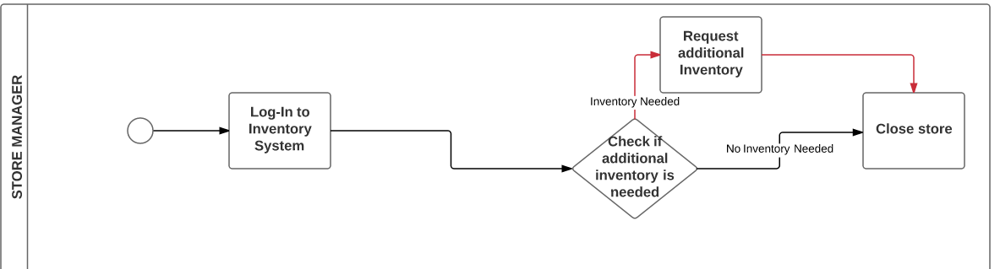

Main/Basic Flow(s) of Events (Happy Path)

Manager opens store.

Manager accesses inventory system.

View previous night’s report.

Manager closes store.

System records inventory changes in report.

Alternate/Exception Flow of Events
  - Additional Inventory
    - Log in to inventory
    - Additional inventory needed
    - Store Request Inventory
    - Request additional inventory
    - Write Store Inventory Request
    - Close Store
  - No Additional Inventory
    - Log in to inventory
    - View previous night report
    - Additional inventory not needed
    - Close store

Assumptions/Business Rules including Non-Functional Requirements
Reports will contain an item whose stock order has been changed and by how much it was changed.

Use Case Specification Review and Signoff
Name | Project Team Role | Signature | Date
Erik Johnson | Team Lead | EJ | 3/24/17
Durwin Johnson | Developer | DJ | 3/24/17
Alex Pope | Developer | AP | 3/24/17
Cindy Samano | Developer | CS | 3/24/17
Fnu Jirigesi | Project Manager | FJ | 3/24/17
Erik Johnson | Team Lead | EJ | 4/27/17
Durwin Johnson | Developer | DJ | 4/27/17
Alex Pope | Developer | AP | 4/27/17
Cindy Samano | Developer | CS | 4/27/17
Fnu Jirigesi | Project Manager | FJ | 4/27/17
Wenhao Zhang | Project Manager | WZ | 4/27/17

